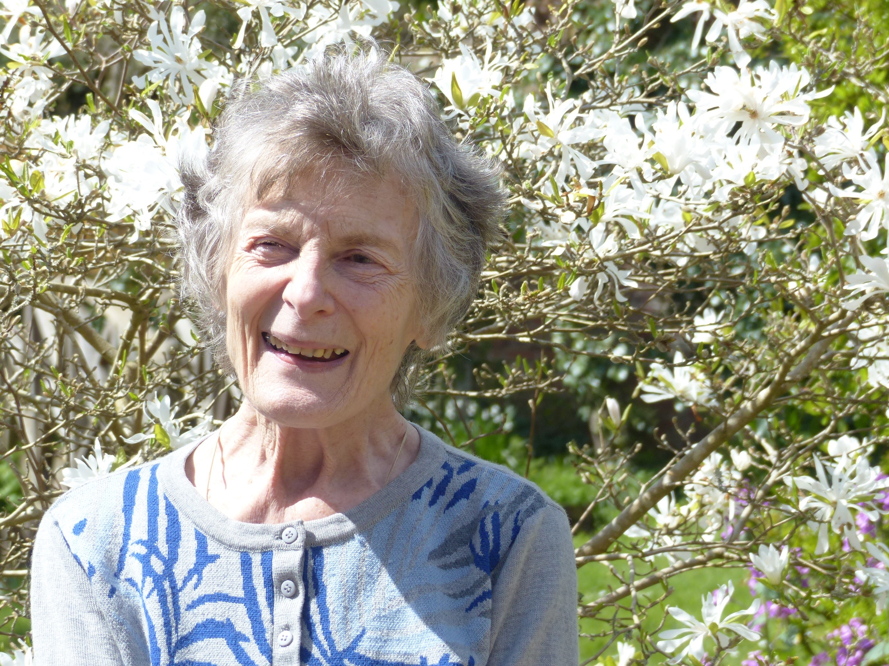
Wedgwood Sandra

Index number: MWOH002010

Recorded on: Thursday 28th April 2016 by Anne Weaver and Roger Davis
Time commenced: 11.00 Duration: 75 minutes Location: Pixham Mill, Pixham, Dorking.

Sandra Wedgwood ( née Gordon-Clark ) was born at home in Battersea in 1938. At the outbreak of the War she, along with her mother and brother, moved to Scotland before returning south to live in Leatherhead, re-joining her father who was working as a barrister in London. Soon their 3-bedroom house became rather cramped as there was a live in Nanny and Sandra’s sister was born. In the early 1950s the family moved to a more spacious house, Berrys Croft in Westhumble, which was her home until her marriage to Martin Wedgwood in 1963. Shortly after their marriage Martin was appointed as the manager for Wedgwood in the West of Canada and he and Sandra moved to Vancouver for three years. Following this Martin was appointed the manager for Europe and on their return they spent the following 6 years in a terraced house in London. During this time difficulties at the family company, Wedgwood, meant that Martin left and took up a career as a stockbroker. Their final move was to Pixham Mill in 1972, which enabled them to be closer to Sandra’s widowed mother. We then hear of Sandra’s earliest memories, which include recollections of her schooling, initially in Leatherhead and subsequently at Guildford High School. She recounts how, from the age of 8, she would travel by train to school in Guildford. Turning to the subject of food Sandra tells us that her mother cooked in the rather dark kitchen in Leatherhead, assisted by the Nanny. She describes how food was stored in the larder and of the need to avoid food waste during the war. Recalling shopping with her mother, we hear of trips to Sainsbury’s in Leatherhead. We are then told about the range of vegetables and fruit grown by her father in the Garden at the Leatherhead house. Next Sandra relates tales about her Grandparent’s retired butler, Poole, including his visits to Berrys Croft, his refusal to allow his daughter to go to Grammar School and of his gift of a barograph. She then goes on to tell us about the cats the family kept when they lived in Leatherhead. Following this we hear of her Father’s involvement in the Home Guard and of the sad loss of her Uncle Roger in action in wartime Italy. Returning to the subject of Berrys Croft, Sandra tells how life changed in the much larger house, and of visits to Hylton-Foster family at Old Dene. At this time her father, as well as being a renown author, was an high court Judge and would hold grand dinner parties using one of the court bailiffs as a waiter. Having only one car meant that her mother would have to catch a bus to shop in Dorking but following Sandra’s Grandmother’s death the family inherited a second car.
We then hear details of her Father’s legal career and mention is made of some other members of the family who lived locally. Sandra then tells us how, on leaving school, she went to Florence where she learnt Italian and spent time visiting museums, art galleries and churches. On her return, in 1956, she decided to study art history. She rapidly achieved a-levels in French and Italian, and following a trip to America, enrolled at the Courtauld Institute of Art. We hear a little of her fellow students and that she chose to study the rather unfashionable 19th Century period. Amongst her many eminent tutors was Nikolaus Pevsner and she was able to secure a job with him working on his great series, The Buildings of England. Sandra stresses that getting a job was important as her mother had become widowed in 1956, and her brother was still studying in Oxford. Although still living at home with her mother, Sandra would attend many parties in London and it was there that she met Martin Wedgwood, becoming engaged in 1962. They married at St Michael’s Church, Mickleham in the summer of 1963, but soon after moved to Canada where they made many friends. It was there that their first child, Ralph, was born and the family moved from a flat to a house. Although expecting their second child, Julia, changes at Wedgwood meant returning to England so that Martin could take up the post of European manager. A small house was found in Earls Court, which was soon filled to ceiling with furniture passed on from Martin’s family. We hear that, as it was then the “Swinging Sixties,” London was a fascinating place to live with many exciting changes. Sandra then explains to us how the accommodation was arranged as their third child, Francis, had now arrived and they also employed an au pair. The household budget was £10 a week of which £3 was paid to the au pair. Trips with the pram to either Holland Park or one of the gated garden squares to meet other mothers and children were frequent. At this time it was decided to move further out and, in order to be near to Sandra’s mother, they started to look around the Dorking area, and subsequently moved to Pixham Mill.

