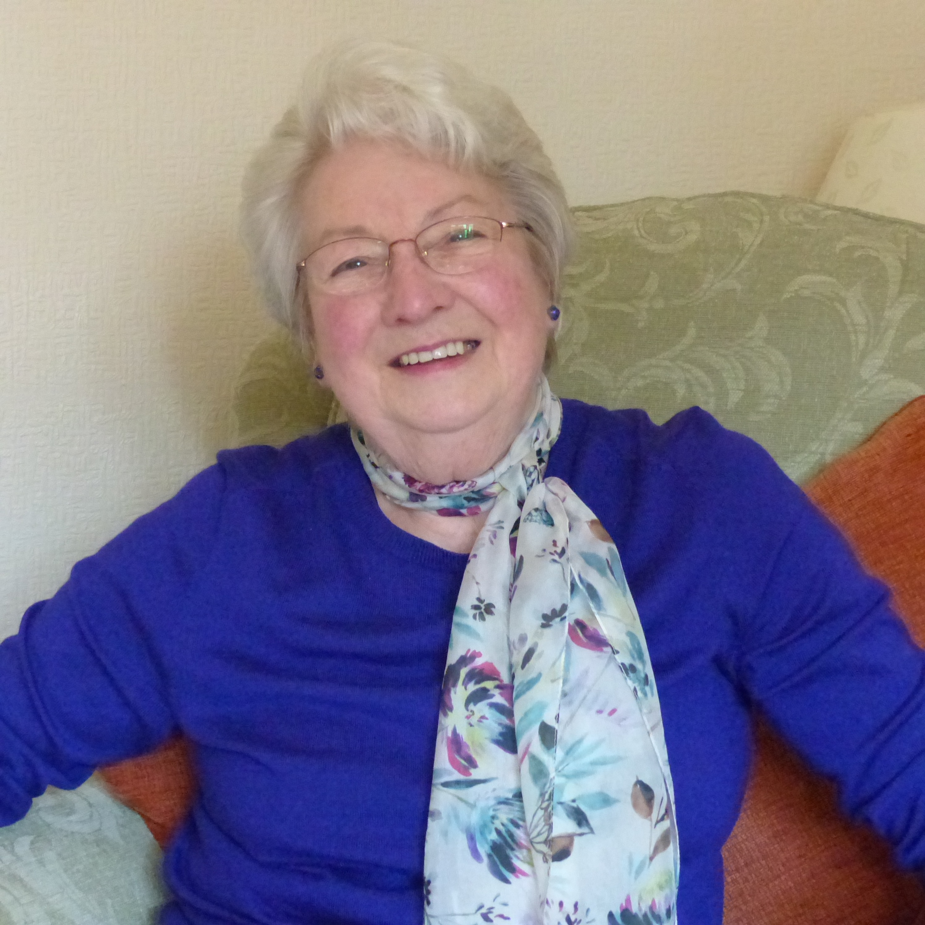
Tobitt Mary

Index number: MWOH002007

Recorded on: Monday 14th March 2016 by Anne Weaver and Roger Davis
Time commenced: 10.30 Duration: 31 minutes Location: 1 Dell Close Cottages, Mickleham, Surrey.

Mary starts by telling us that she has lived all her married life at Dell Close Cottages, Mickleham, but that prior to that she was in Dorking. She worked for 4 years as a cashier and bookkeeper at Chittys, her Godparents butcher’s shop, where she had to deal with the ration books. Cookery skills were learnt both at home and at school. She then talks about the early years of her marriage when her husband Peter was carrying out his National Service. At this time Mary took a part time job at the Home and Colonial Store in Dorking and she relates how the goods were sold, including the slicing of bacon and the weighing of dry products. In 1957 Peter finished his National Service and their son David was born. Another son, Michael, was born in 1959. She then describes how food was bought and how this often involved placing an order for food to be delivered later. As there was no refrigeration in the house, a larder with a meat safe was used. Milk was kept cool in a bucket of water and the eggs, from their own chickens, were preserved by pickling. Vegetables were grown in the garden by Peter. Mary then talks about the food prepared for special occasions. Chicken rather than turkey was normally served at Christmas. In the early days eating out was confined to family picnics and Mary mentions the parties held with the many children in the village. She tells us that she was responsible for all the cooking although she felt that, if necessary, the family were capable of taking over. Like her mother, Mary enjoys baking, something she still does today. Returning to the subject of eating out we hear about the rare trips out to Caesars in Leatherhead or to the Berni Inn at Tattenham Corner. See relates to us the history of the Tobitt family, who lived at Hall Cottages before moving to Dell Close in 1935. At this time there was no hot water system so the bath was downstairs and had to be filled with buckets of hot water. After purchasing the house in 1972, Mary & Peter spent two years modernising the house including the installation of a hot water system. Mary now thinks that at 80 years old she may be one of the oldest residents of the village, although when she first came to Dell Close she believes that she was the youngest married woman in the Close. She then recaps about the food deliveries including Milk from Prewett’s Diary in Leatherhead and deliveries from the butchers. We hear how the supply of offal was restricted in the post war years. Whilst working at Chittys, Mary was responsible for administering the offal rationing, which depended on the first letter of the surname. A sign indicating the letter was placed in the shop window, although we hear that some customers would try to get round this system but that as Mary knew her customers she could prevent this. Sausages were limited to half a pound a week for two people and corned beef to four ounces. Chicken was a luxury usually reserved for Christmas. Attention turns to the Village Hall and we hear how the kitchen was used to cook lunches for the children of St Michaels School, who would walk there. Many of the village mothers would assist as Dinner Ladies. She describes the food provided and tells us that as she often served out the cabbage she was not usually the most popular Dinner lady!

